
53758 - Tall Nature Station V2
 |  |  | 4 |  | 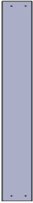 | 2 |  |  | 2 |  |  | 1 |  | 
 |  | 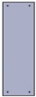 | 9 |  | 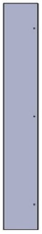 | 1 |  | 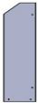 | 2 |  | 3,5x35mm | 62
 |  | 3,5x45mm | 4

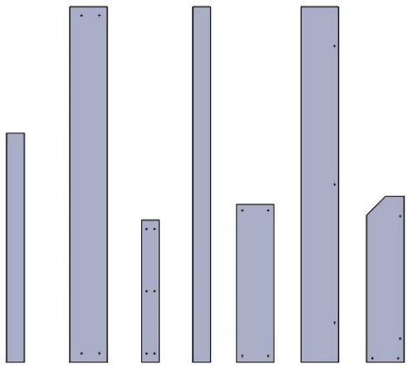  Gx2  Fx1  Ex9  Dx2  Cx2  Bx2  Ax4 |  | 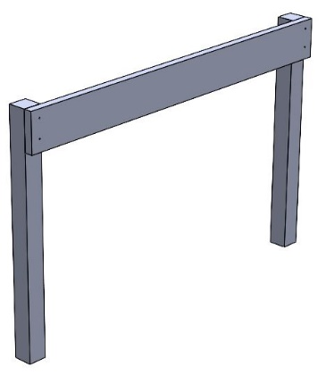  2 x H  2 x H  A  A  B | 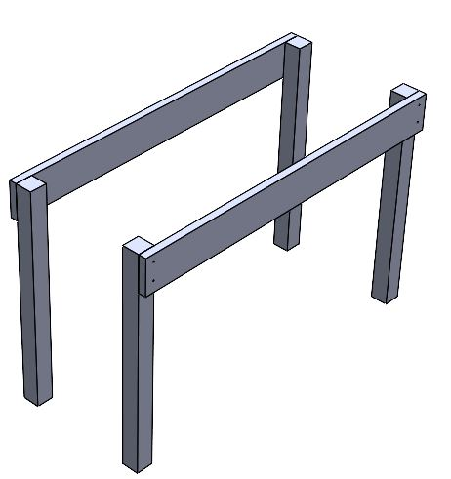  2
1 |  | 2 | 3
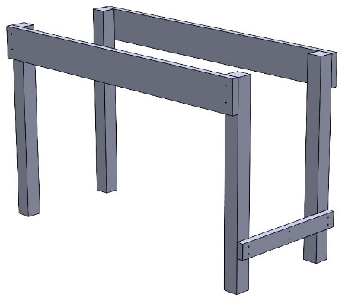  2 x H  2 x H  Cx2 | 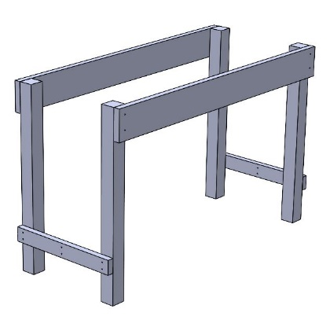  2 x I  4  C | 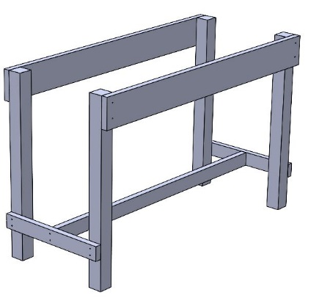  2 x I  D | 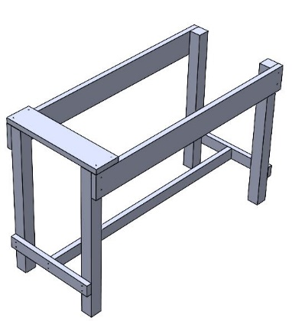  2 x H  2 x H  E
4 | 5 | 6 | 7


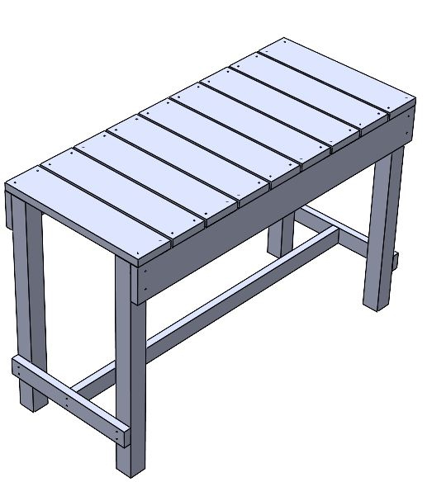  7 | 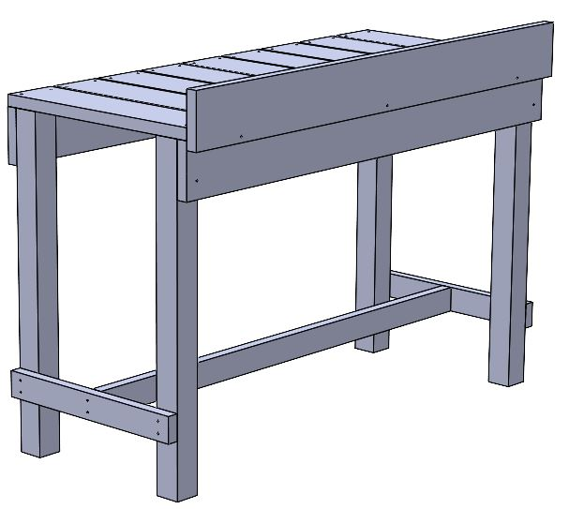  H  H  H  F | 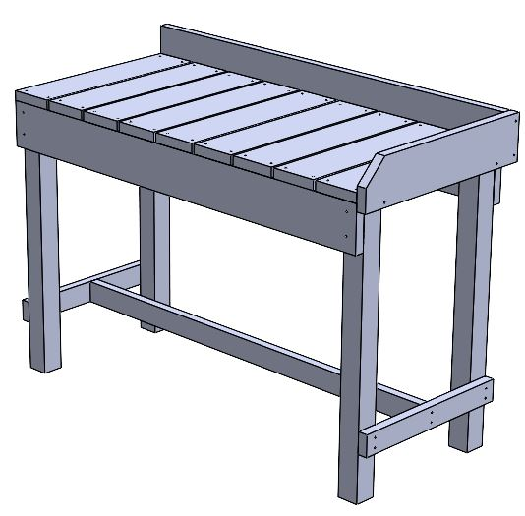  H  H  H  H  G | 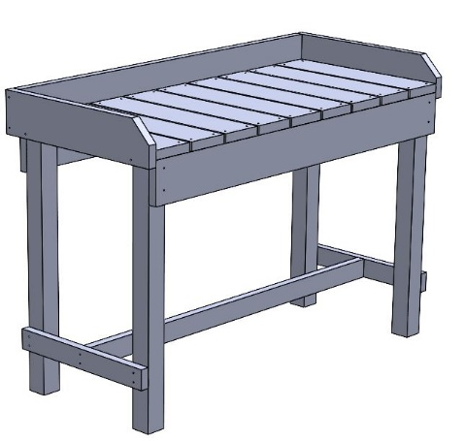  10  G
8 | 9 | 10 | 11
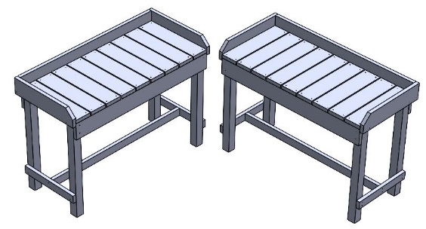
2 – 11
12 – 13

