50374 – Horseshoe Workshop
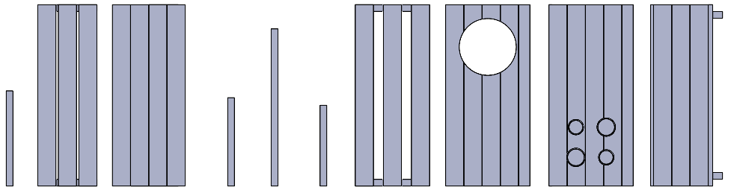  Ax8  Bx4  Fx2  I  H  Ex2  G  Dx2  Cx2 |  | 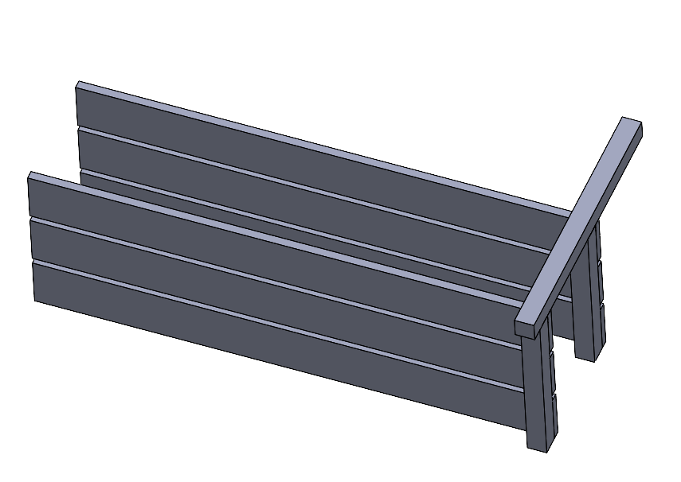  J  J  A  B  B | 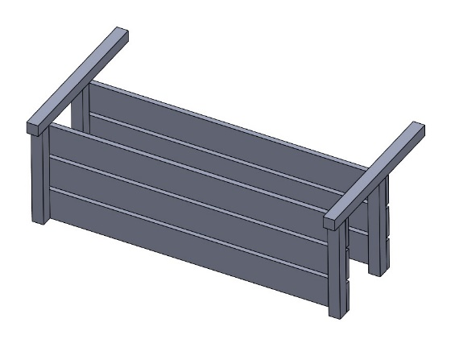  J  J  A
1 |  | 2 | 3
  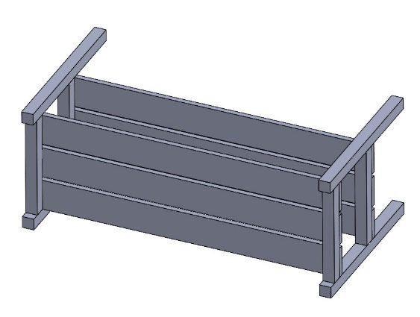  2 - 3  A  A | 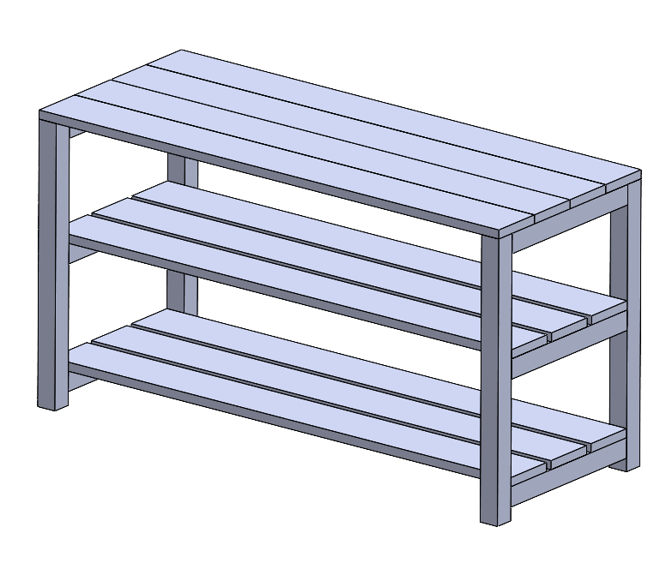  J  J  J  J  C | 2 - 5 | 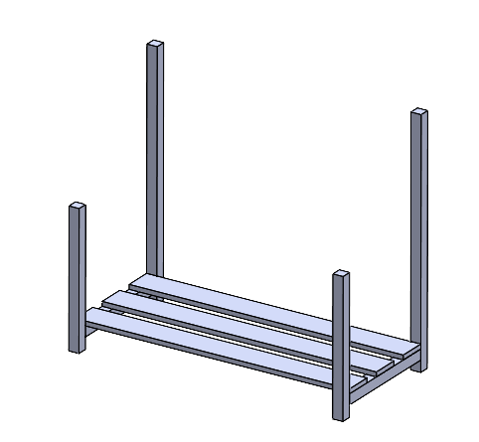  J  J  J  J  G  D  E
4 | 5 | 6 | 7
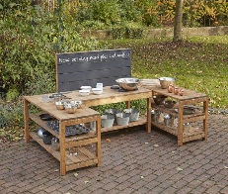 |  |  | 8 |  | 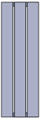 | 4 |  | 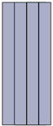 | 2 |  |  | 2 |  | 
 |  |  | 2 |  |  | 2 |  | 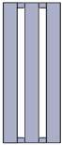 | 1 |  | 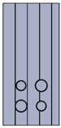 | 1
 |  | 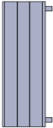 | 2 |  | 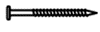 80mm | 40

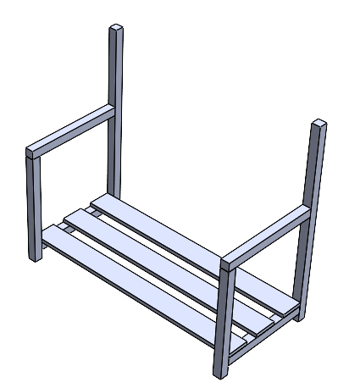  J  J  J  J  F  F | 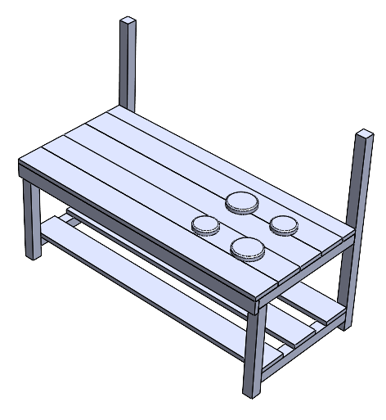  J  J  J  H  J | 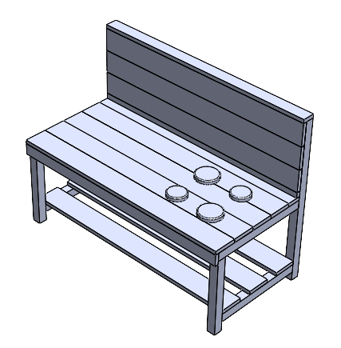  I | 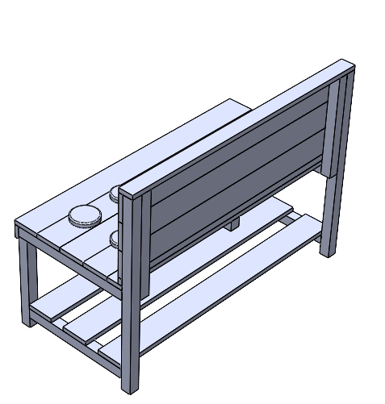  J  J  J  J
8 | 9 | 10 |   11

12

Email us your
ideas@cosydirect.com
