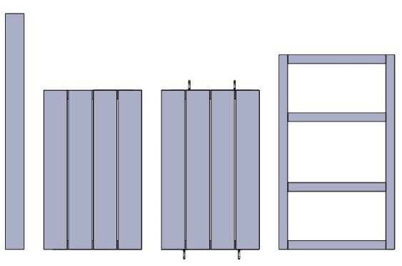  D  C  Ax4  B | 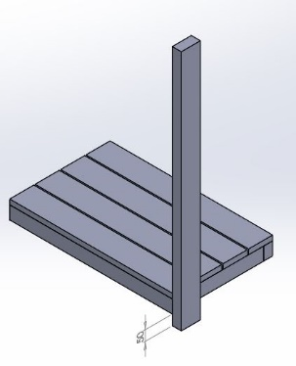  2 x E A  B  A |   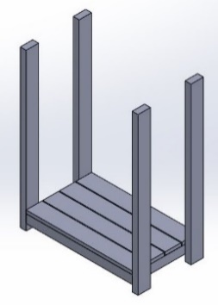  2  A  A  A | 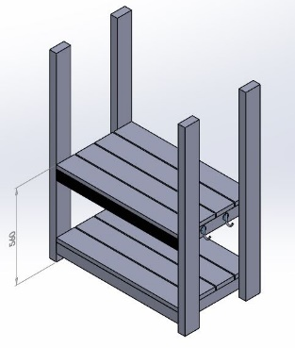  2 x E A  2 x E A  2 x E A  2 x E A  C
1 | 2 | 3 | 4
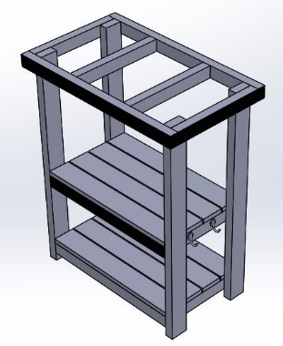  2 x E A  2 x E A  2 x E A  2 x E A  D | 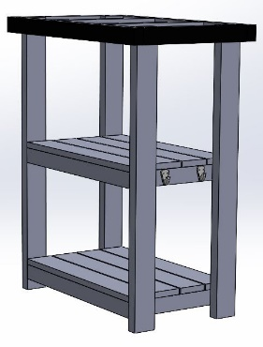  F & 2x G  F & 2x G | 
5 | 6 | 7

48353 – KS1 Simple Shop
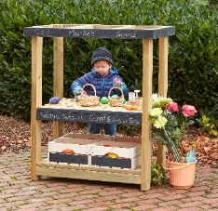 |  |  | 4 |  | 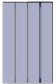 | 1 |  | 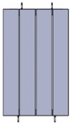 | 1 |  | 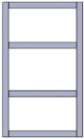 | 1 |  | 
 |  | 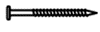70mm | 24 |  | 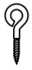 | 4 |  | 25mm | 8 |  |  |  |  | 


Email us your
ideas@cosydirect.com
