48327 – T Work Table
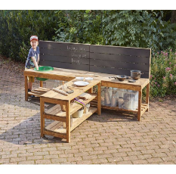 |  |  | 4 |  | 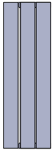 | 2 |  | 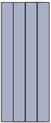 | 1 |  |  | 4 |  | 
 |  |  | 2 |  |  | 4 |  | 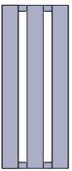 | 2 |  | 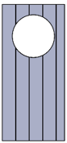 | 1
 |  | 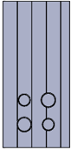 | 1 |  | 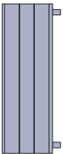 | 2 |  | 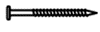 80mm | 44
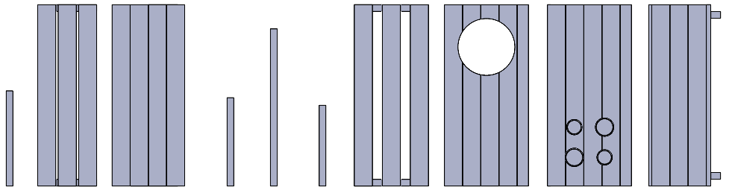  Gx2  Jx2  I  H  Fx2  Ex4  Dx4  C  Ax4  Bx2 |  |  | 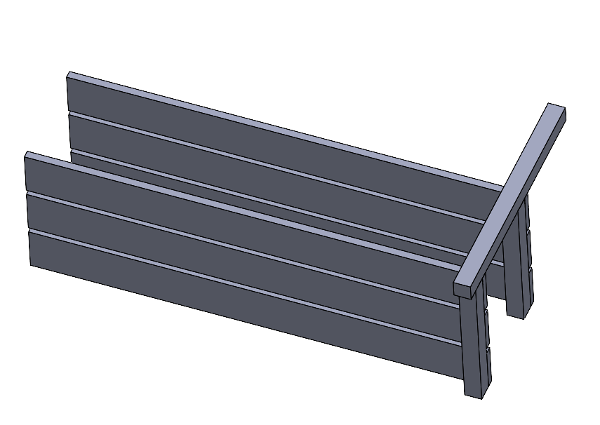  2 x K  A  B  B
1 |  |  | 2
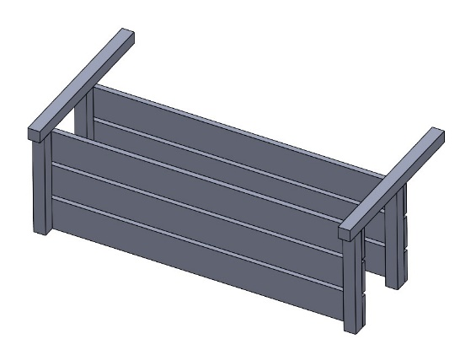  K  K  A |   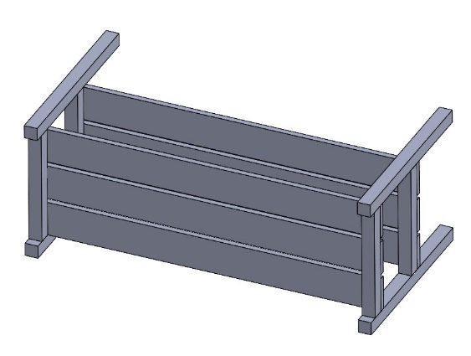  2 – 3  A  A | 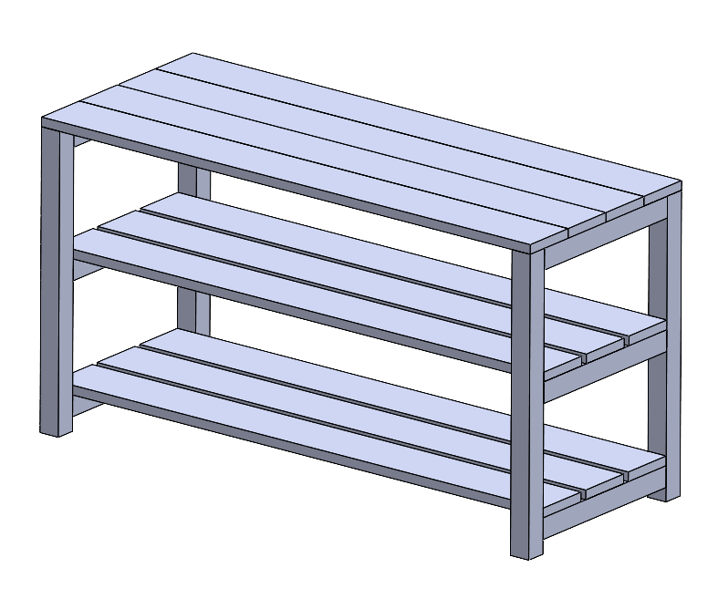  K  K  K  K  C | 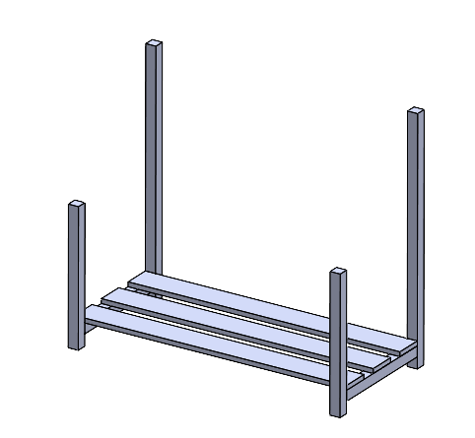  K  K  K  K  D  D  E  E  G
3 | 4 | 5 | 6

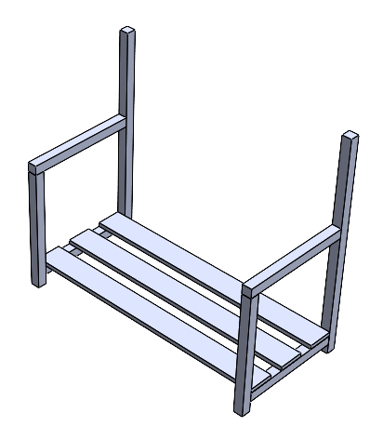  K  K  K  K  F  F | 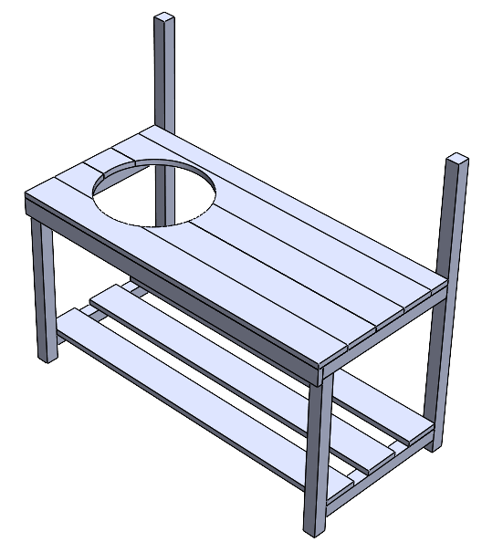  K  K  K  K  H | 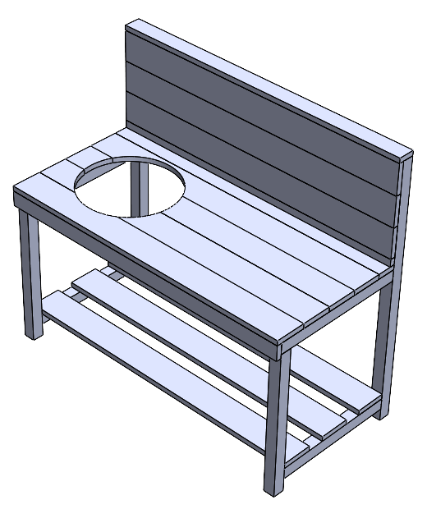  J | 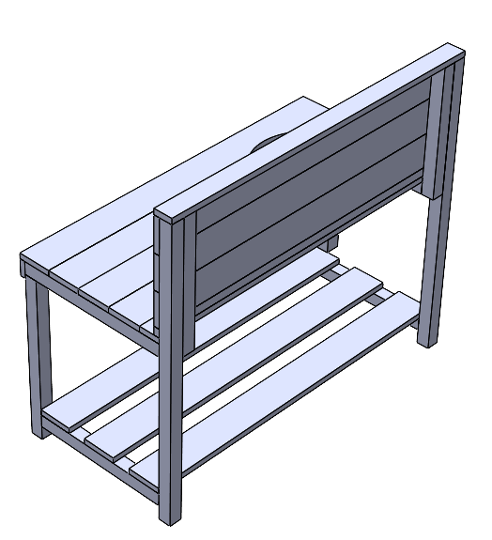  K  K  K  K
7 | 8 | 9 |   10
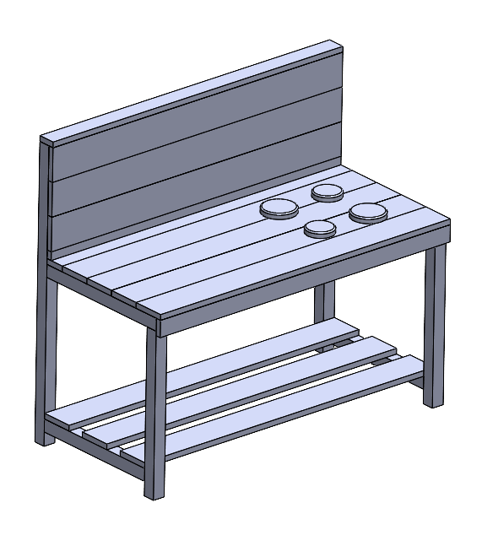  6 – 10  – 3  I | 
11 | 12

