
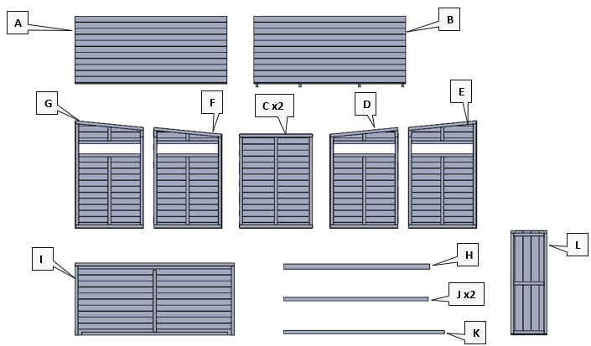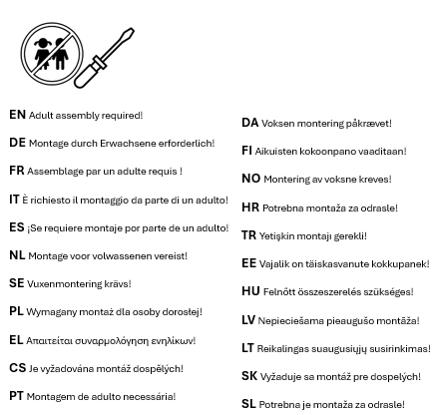

35737 – Closed Forest Cabin
 |  | 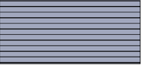 | 1 |  | 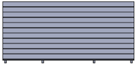 | 1 |  | 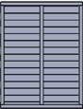 | 2 |  | 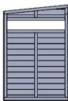 | 1 |  | 
 |  | 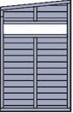 | 1 |  | 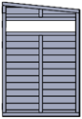 | 1 |  | 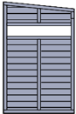 | 1 |  |  | 1 |  | 
 |  | 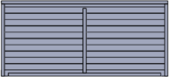 | 2 |  |  | 2 |  |  | 1 |  | 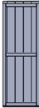 | 2 |  | 
 |  | 80mm | 43 |  | 30mm | 12 |  | 50mm | 18 |  | 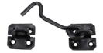 | 2
 |  | 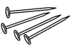 | 1 |  | 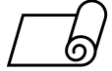 | 1

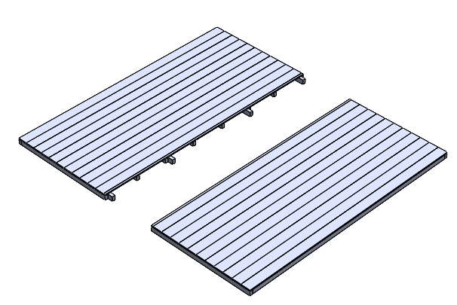  B  A | 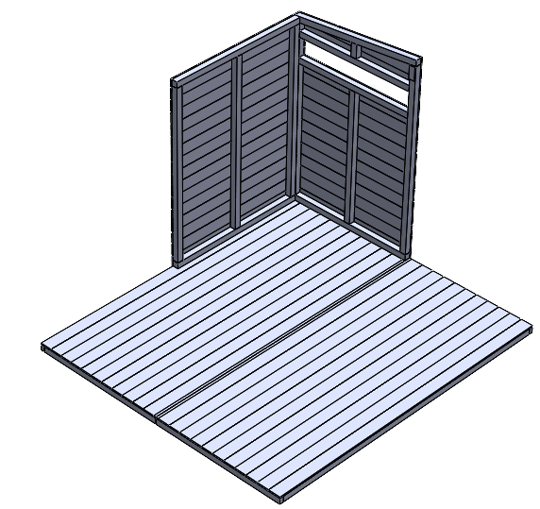  Mx2  M  M  M  M  M  .  .  .  .  .  .  .  D  C | 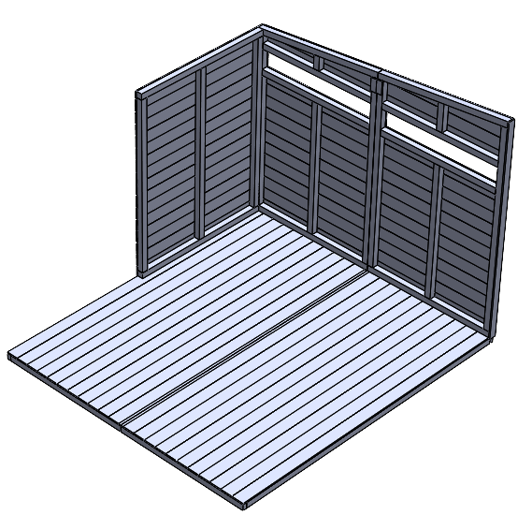  Mx2  M  M  M  .  .  E  .  .  . | 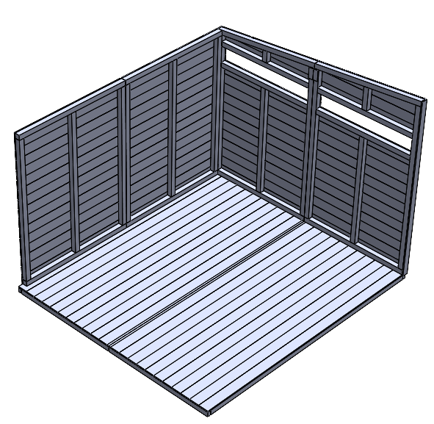  M  M  M  Mx2  .  .  .  .  .  C
 | - . | - .
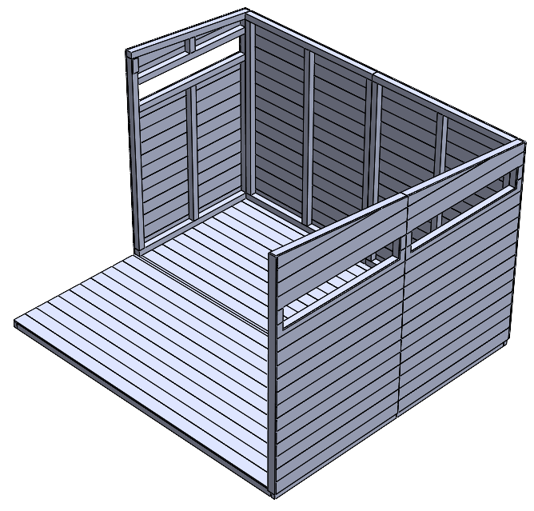  M  M  M  M  M  .  F  .  .  .  . | 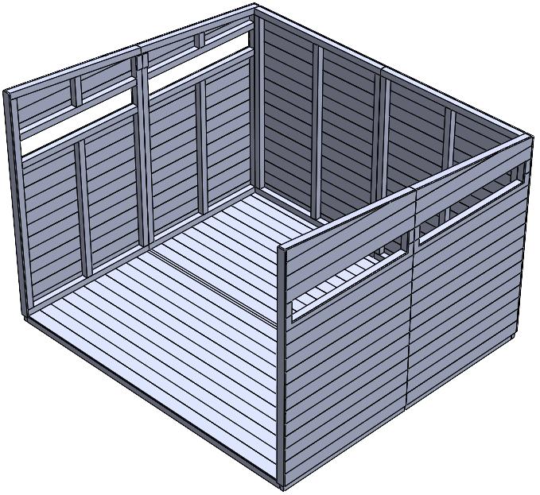  M  M  Mx2  M  .  .  .  .  .  G | 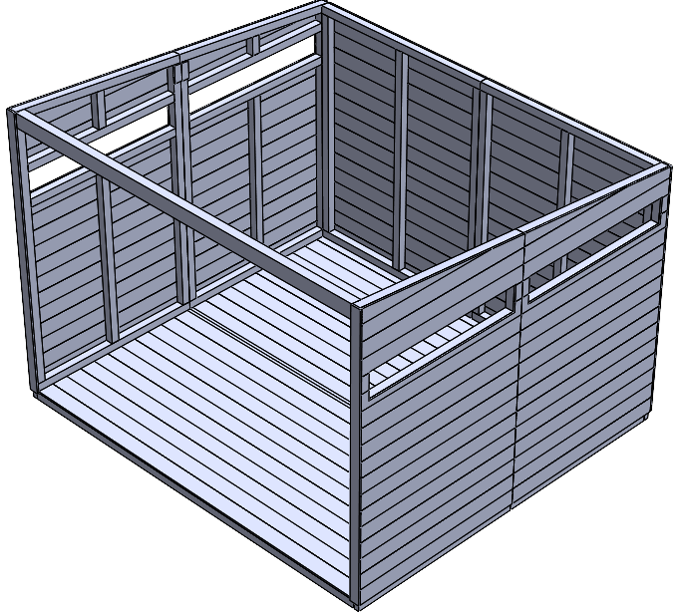  Mx2  Mx2  H | 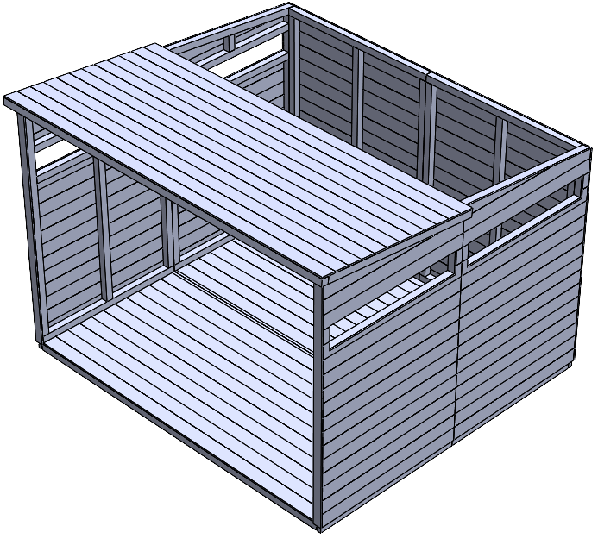  I

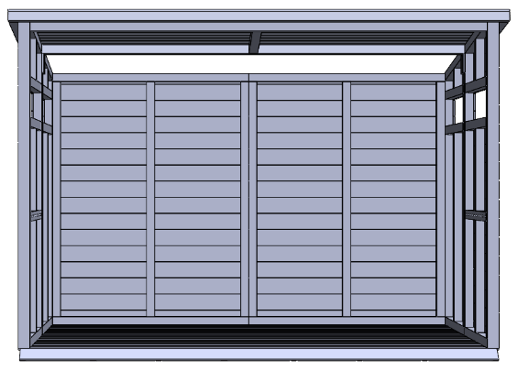  Mx2  Mx2 | 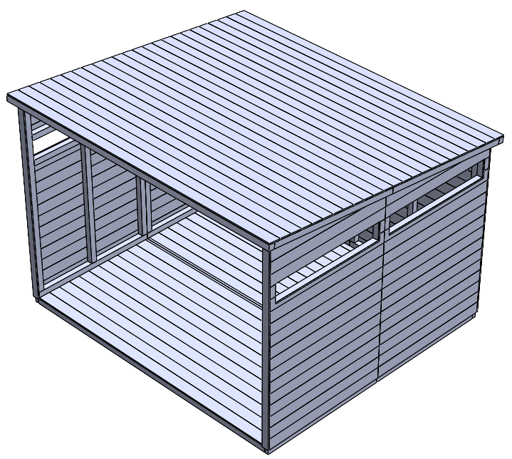  I | 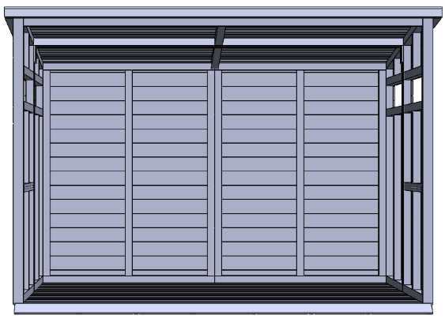  Mx8
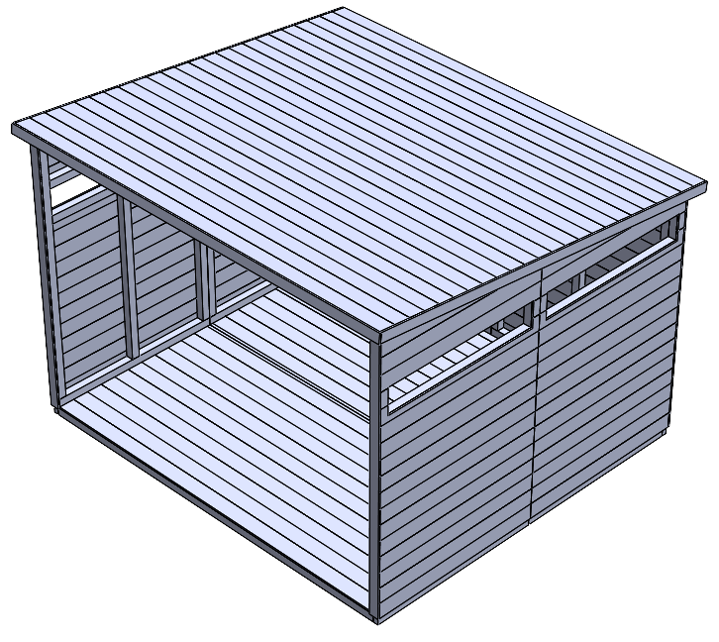  Nx12  K  J  J  .  . | 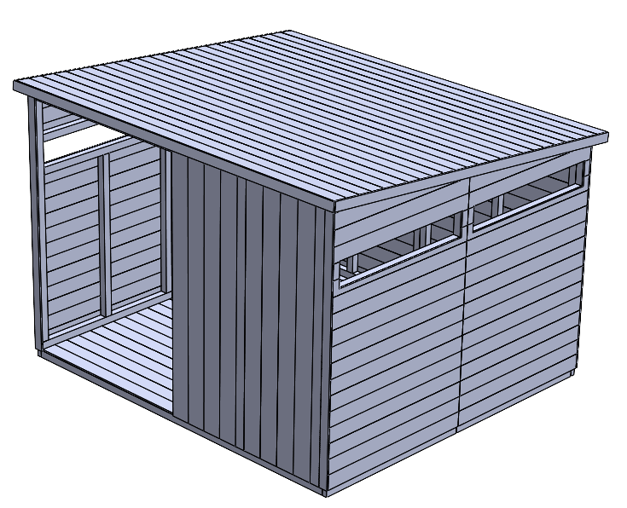  O  O  O | 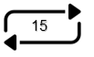  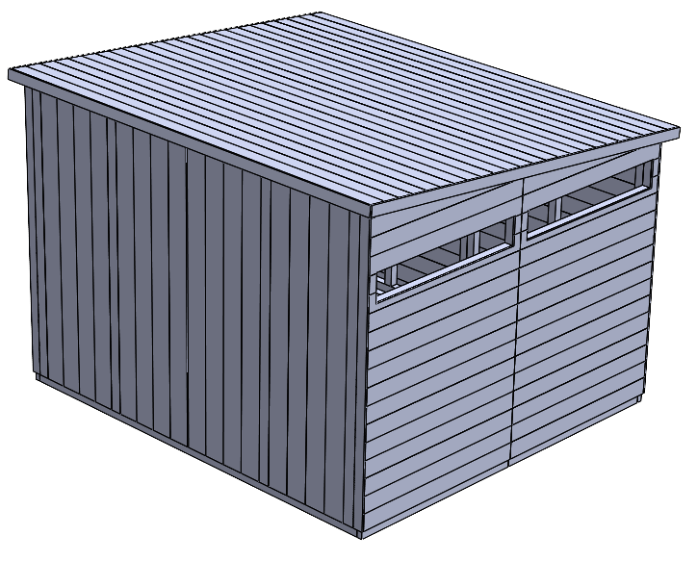  O  O  O | 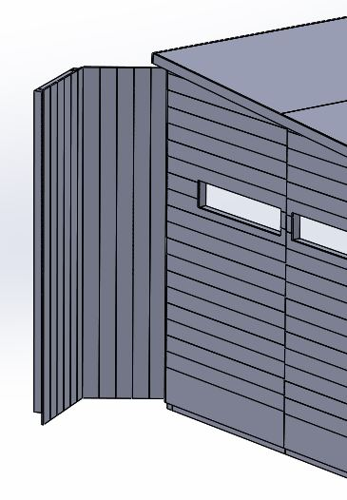  P  P

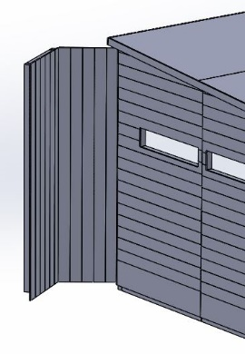  P  P |   