35727 – Outdoor Welly Storage (Mobile)
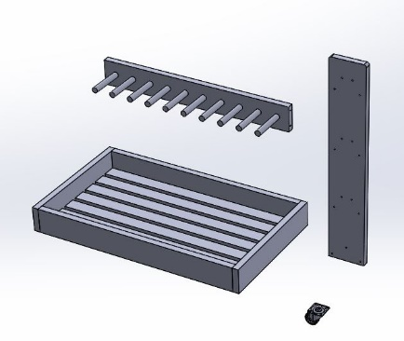  Dx4  Cx6  A | 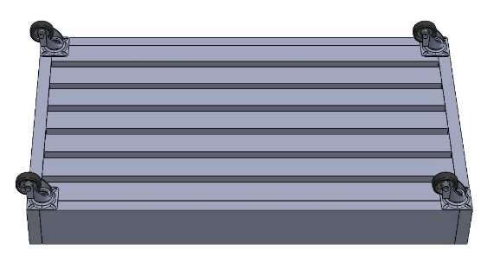  4 x F  4 x F  4 x F  4 x F  D  D  D  D  A | 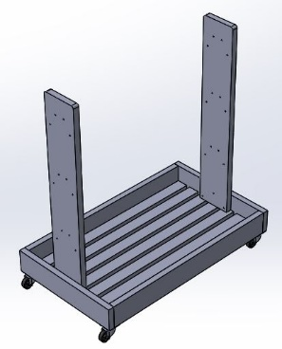  G  G  G  G  B  B | 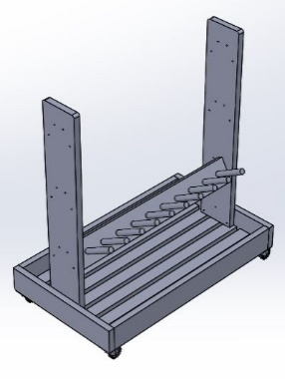  H  H  H  H  C
 | Bx2
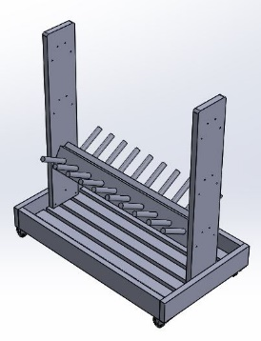  H  H  H  H  C | 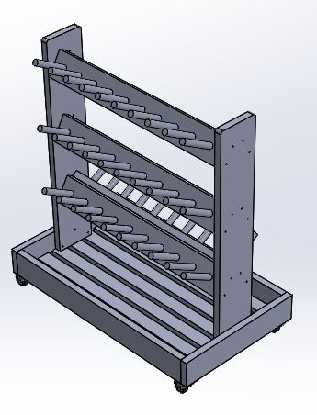  H  H  H  C  H  H  H  H  H  C | 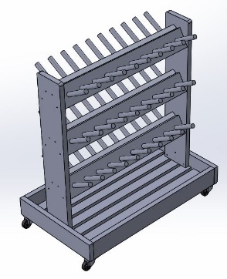  H  C  H  H  H  H  H  H  H  C | 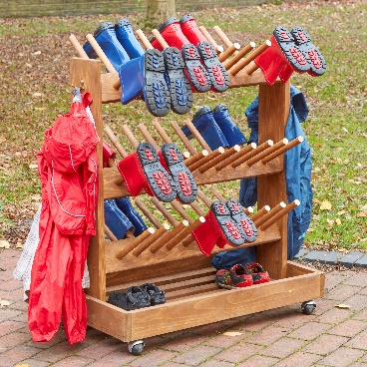
- 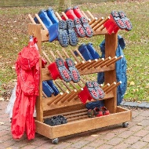 | Part |  | Name | Qty | Part | Name | Qty | Part | Name | Qty | Part | Name |  | Qty |  | Tools Required
 |  |  | 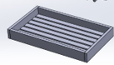 | 1 |  |  | 2 |  | 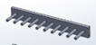 | 6 |  |  |  | 4 |  | 
 |  |  |  | 6 |  | 25mm | 16 | G. | 50mm | 4 | H. | 90mm |  | 24

