35286 – Mud Pie Kitchen Cafe
 |  |  | 1 |  |  | 1 |  |  | 2 |  |  | 2 |  | 
 |  |  | 6 |  |  | 2 |  |  | 2 |  |  | 1 |  | 
 |  | 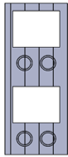 | 1 |  |  | 1 |  |  | 1 |  |  | 1 |  | 
 |  |  | 1 |  |  | 2 |  |  | 1 |  | 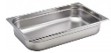 | 2
 |  | Bracket | 1 |  | 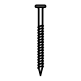16mm | 4 |  | 25mm | 8 |  | 30mm | 14
 |  | 40mm | 46 |  | 55mm | 8 |  | 70mm | 22
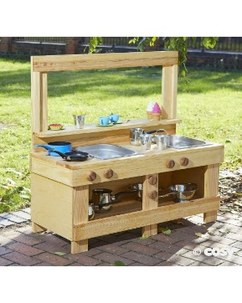
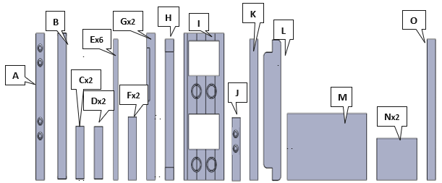  .  .  .  .  .  .  .  .  .  .  . |  |  |  | 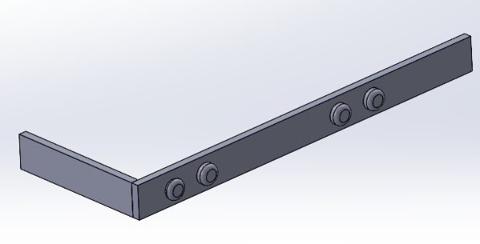  W  W  .  .  C  A
.
.
.
.
.
.
  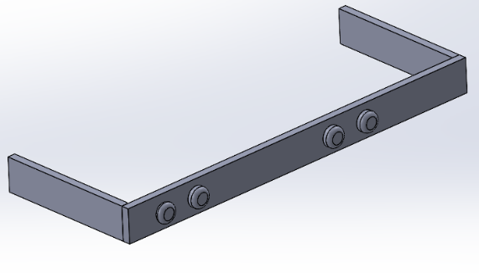  W  W  2  .  .  C | 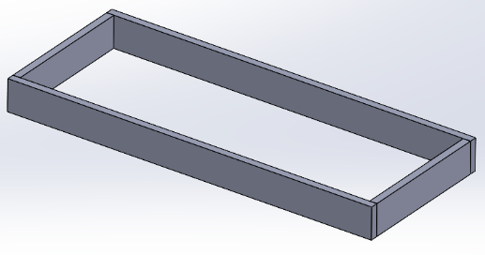  W  W  W  B  W  .  .  .  . | 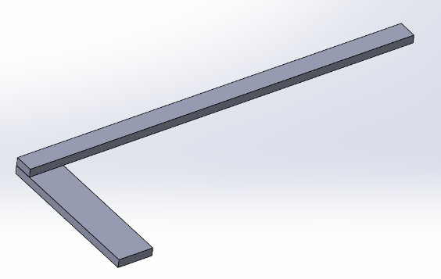  V  V  .  .  D  E | 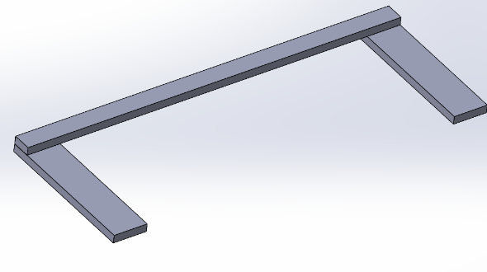  V  V  .  .  D

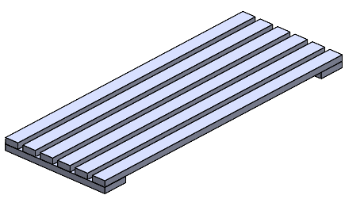  E  E  E  E  E  5-6  .  .  .  .  .  .  .  .  .  .  .  .  .  .  .  .  .  .  .  . | 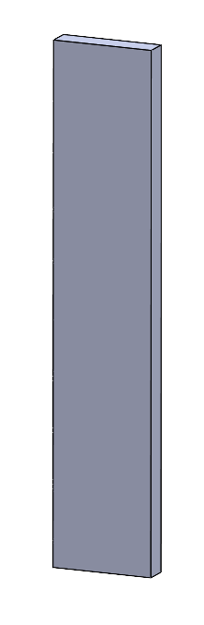  6.5cm  F | 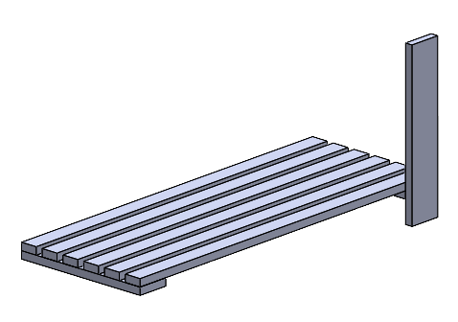  W  W  .  .  F | 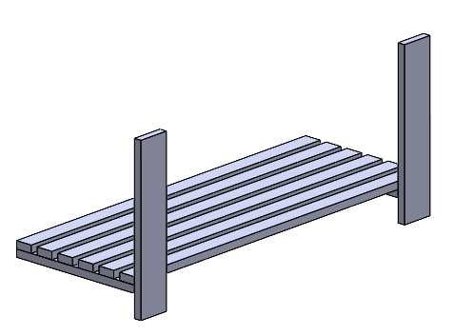  9  W  W  .  .  F
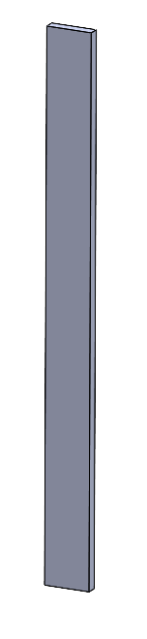  36.5cm  6.5cm  G | 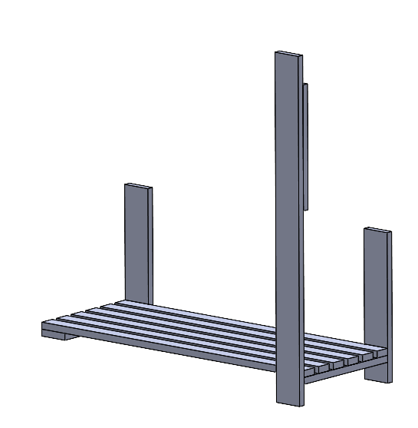  W  W  .  .  G | 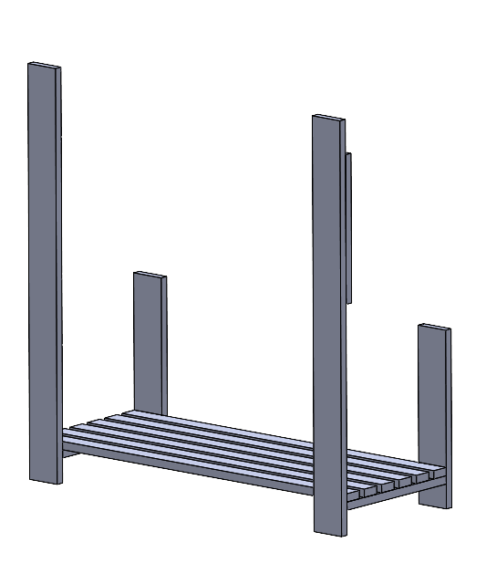  12  W  W  .  .  G | 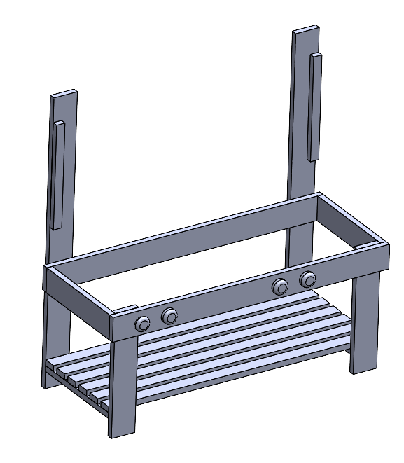  V  V  V  V  .  .  .  .

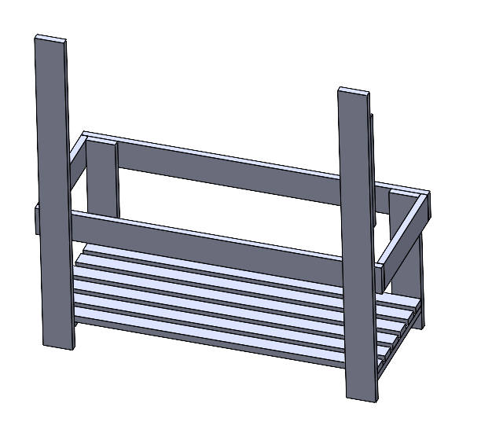  U  U  .  .  .  .  .  .  . | 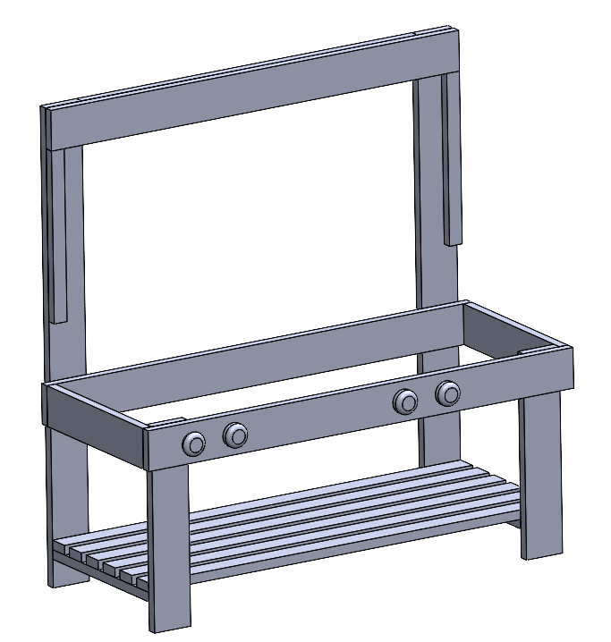  S  S  S  H  S  S  S  S  S  .  .  .  . | 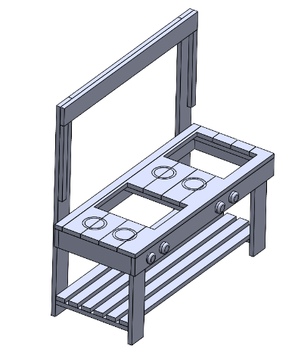  Ux18  .  .  .  .  .  .  .  .  .  .  .  .  .  .  .  .  I | 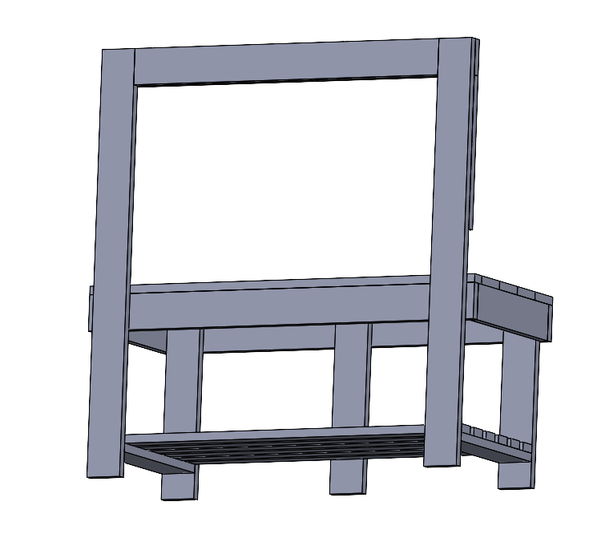  U  U  .  .  J
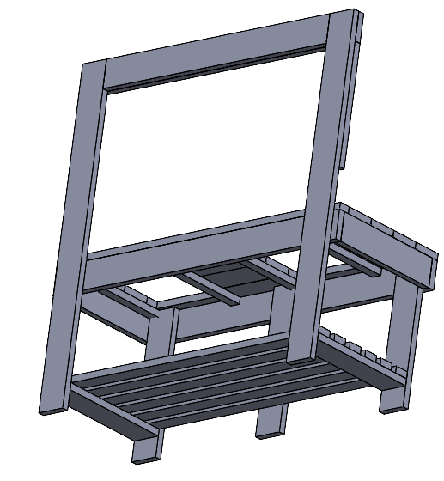  Q  R  R  R  R  .  .  .  . | 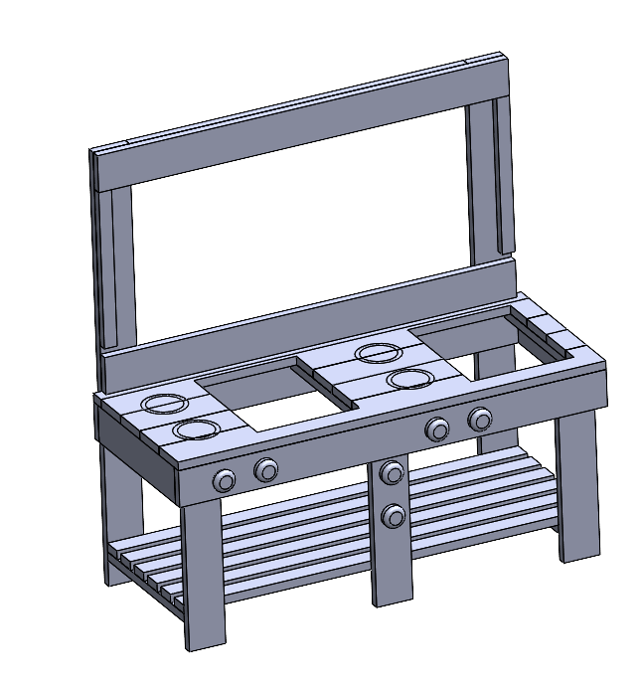  V  V  V  V  K  .  .  .  . | 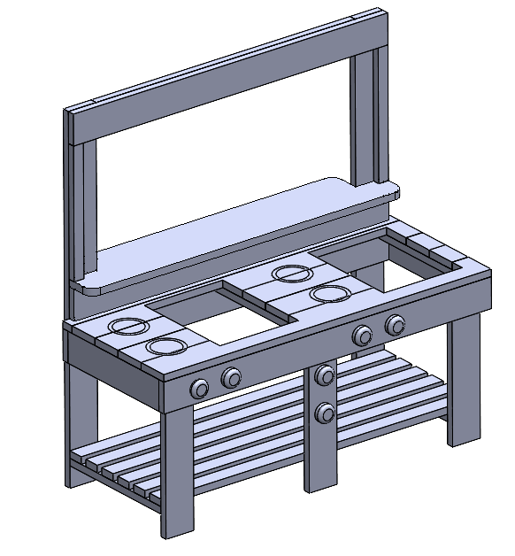  W  W  W  L  .  .  . | 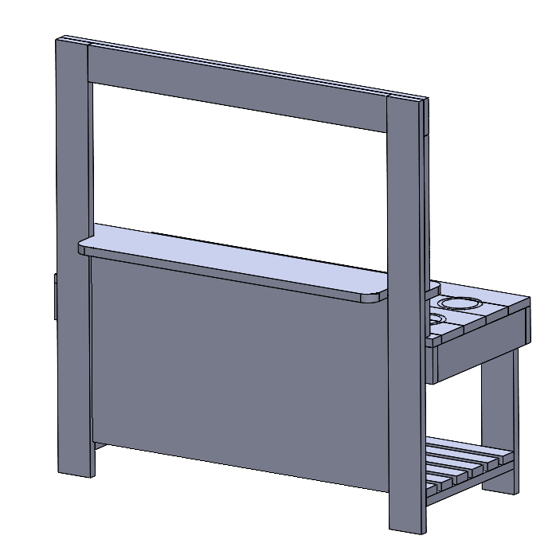  T  T  T  T  T  T  .  .  .  .  .  .  M
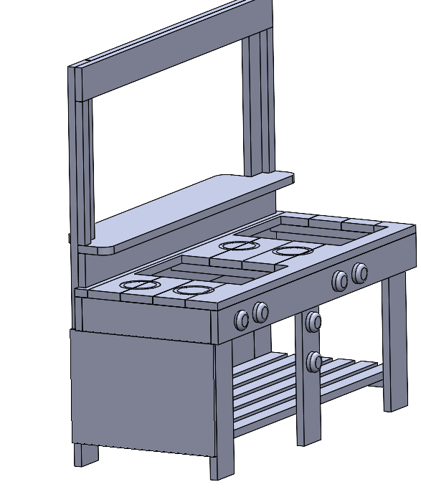  T  T  T  T  N  .  .  .  . | 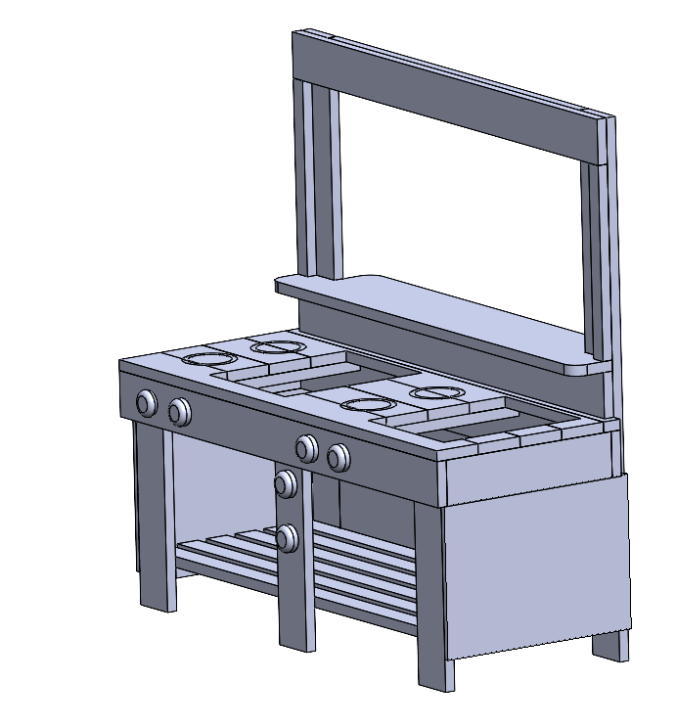  23  T  T  T  T  .  .  .  .  N | 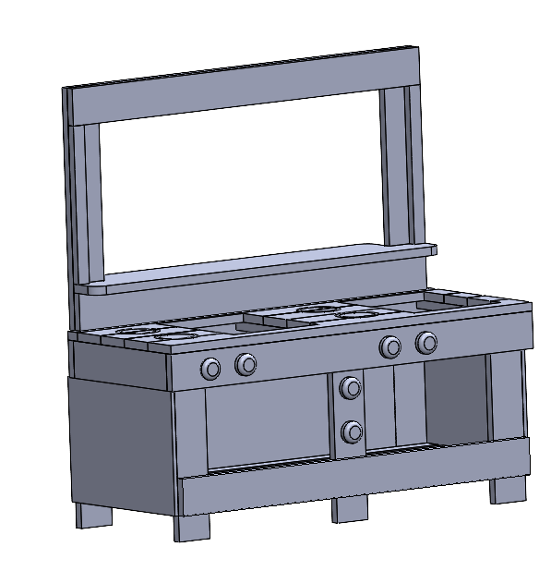  U  U  U  U  U  U  .  .  .  .  .  .  O | 

