 |  | (5 holes) | 1 |  | (6 holes) | 1 |  | (3 holes) | 1 |  | 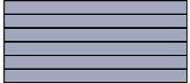 | 1
 |  |  | 1 |  |  | 1 |  |  | 1 |  |  | 1
 |  | 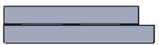 | 1 |  | 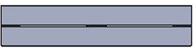 | 1 |  |  | 1 |  |  | 1
 |  |  | 1 |  |  | 24 |  | 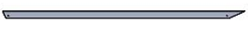 | 1 |  | 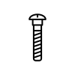100mm | 8
 |  | 80mm | 6 |  | 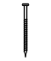45mm | 36 |  | 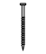35mm | 12 |  | 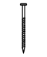75mm | 4
 |  | 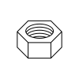100mm | 8 |  | for 100mm | 8 |  | 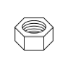for 80mm | 6 |  | for 80mm | 6
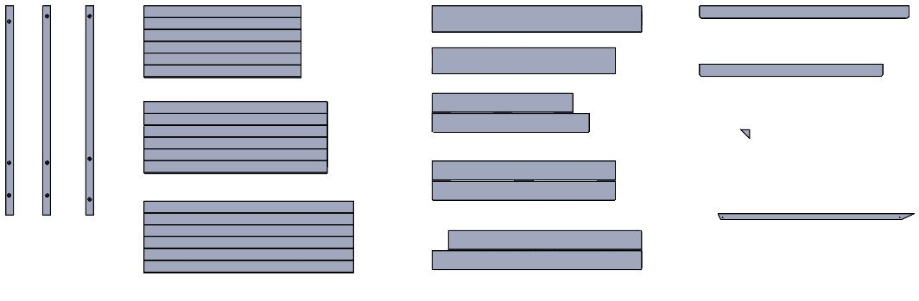
O
N
M
L
G
H
I
J
F
E
D
C
A
B
K

35028 – Open Ended Role Play Area

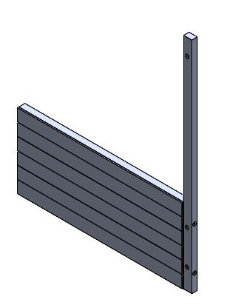  P  P  D  A | 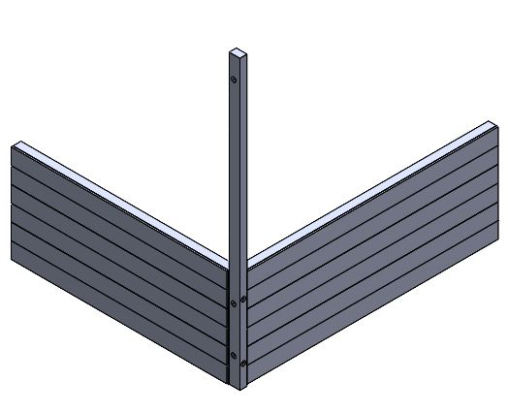  Q  Q  E | 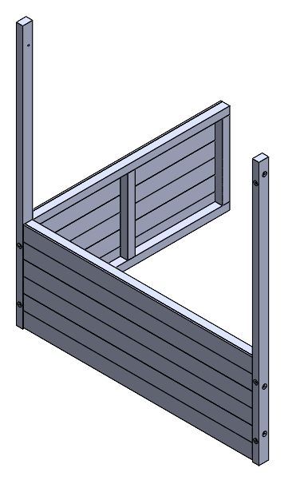  Q  Q  B | 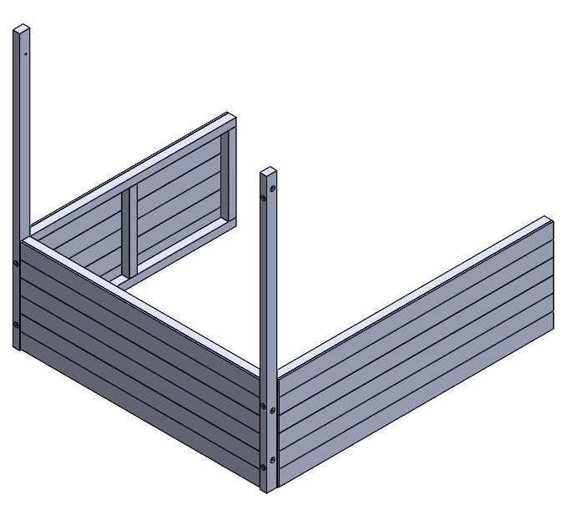  P  F
 |  | - . | P
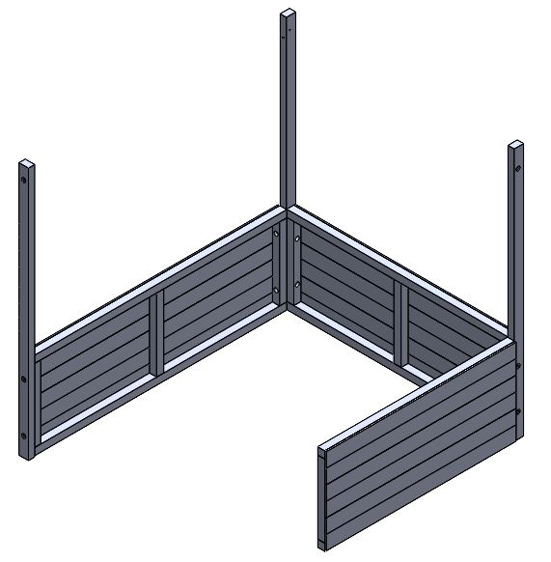  P  P  C | 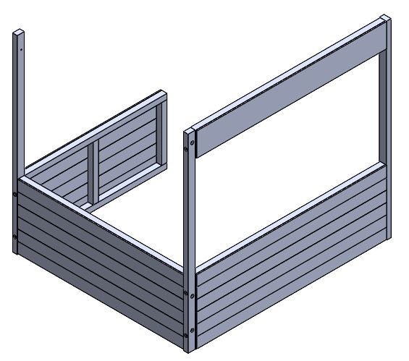  P  P  G | 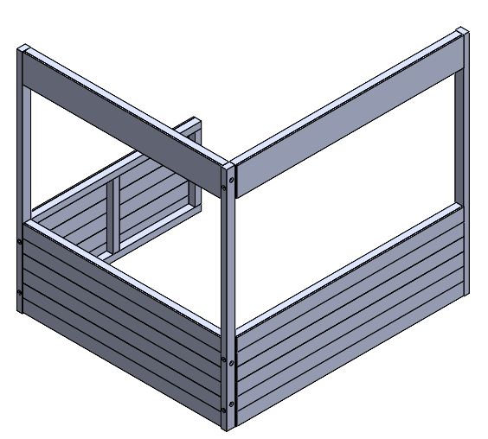  Q  Q  H | 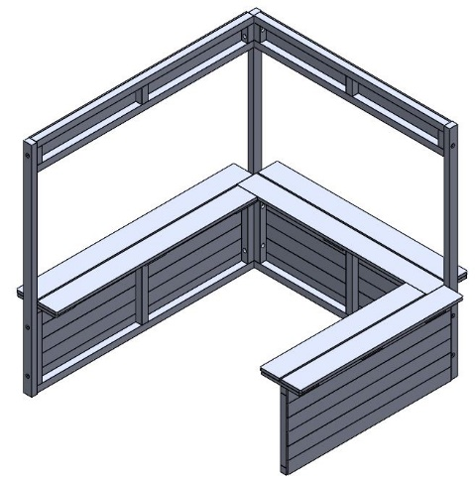  K  J  I

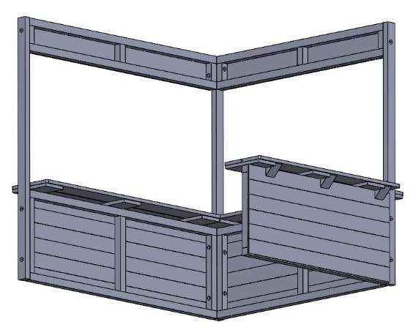  N  N  R  R  R  N | 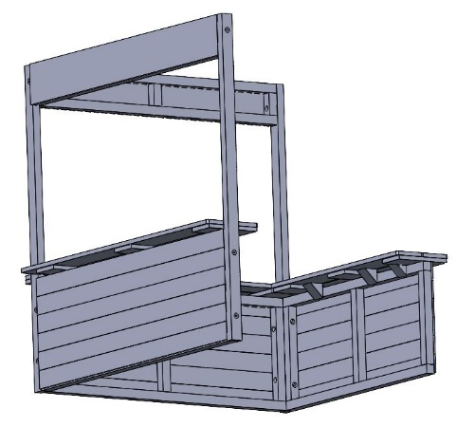  R  R  R  N  N  N | 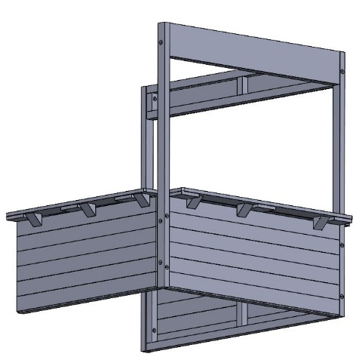  N  R  R  R  N  N | 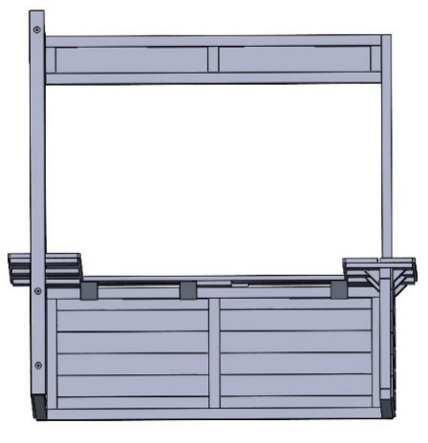  R  R  R  N  N  N
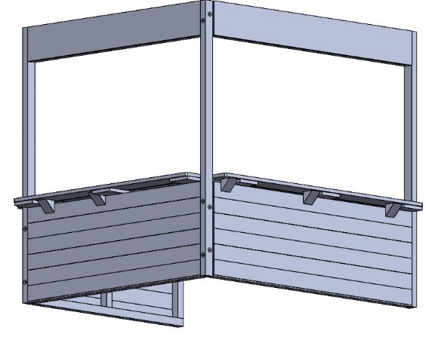  R  R  R  N  N  N | 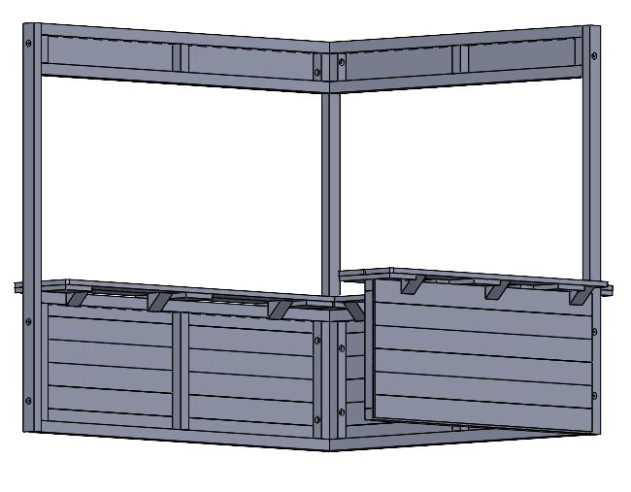  R  R  R  N  N  N | 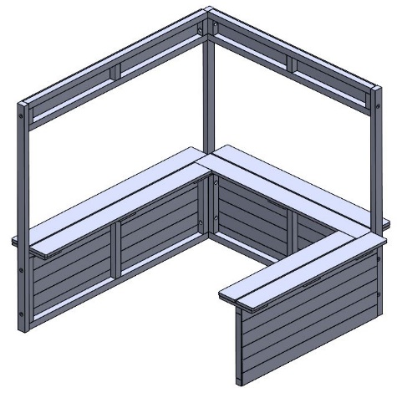  Rx18 | 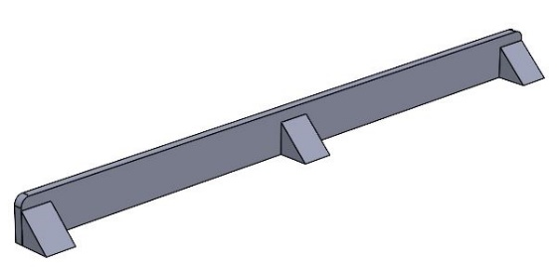  N  N  L  N

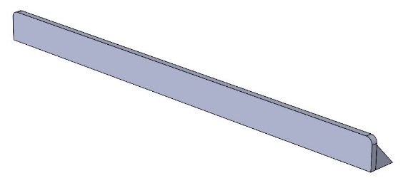  S  S  S | 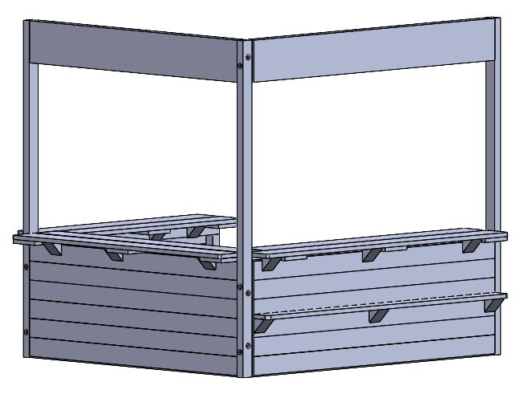  S  S  S  F | N  N  M  N | S  S  S
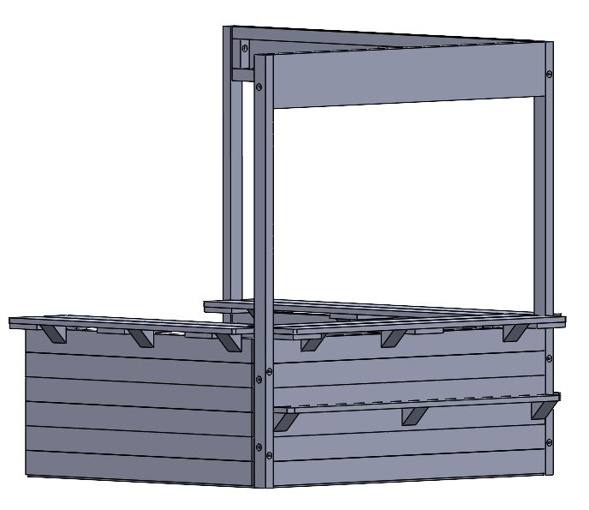  S  S  S  E | 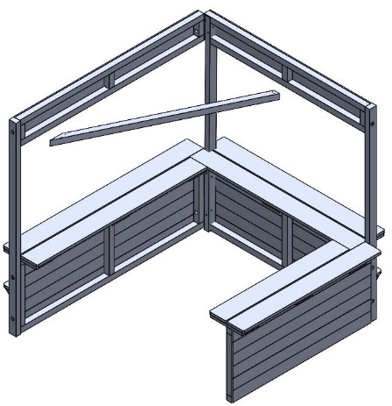  O | 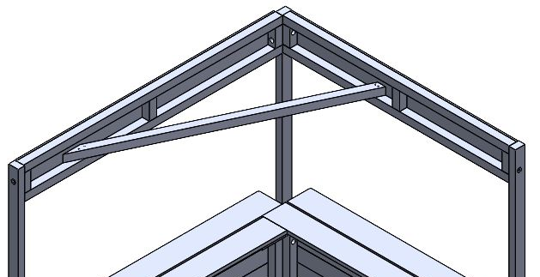  T  T  T  T | 