28230 – Sand & Water Tray & Stand
  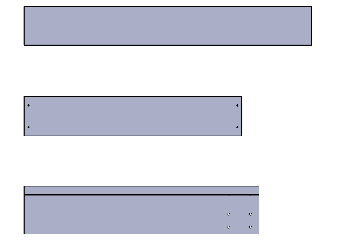  Cx4  Bx2  Ax2 |  | 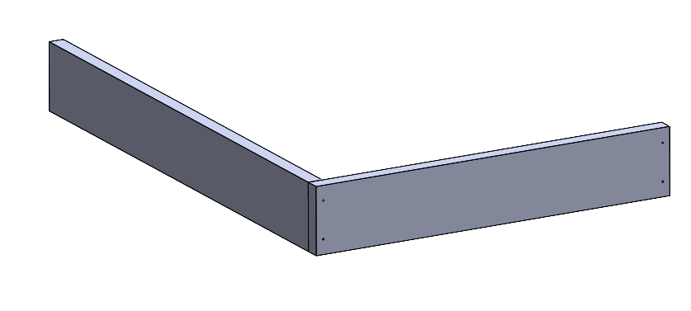  D  D  D  D  B  A | 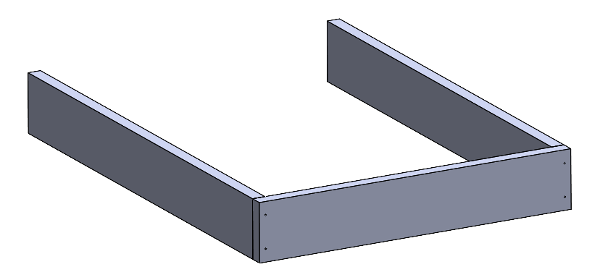  D  D  D  D  A
1 |  | 2 | 3
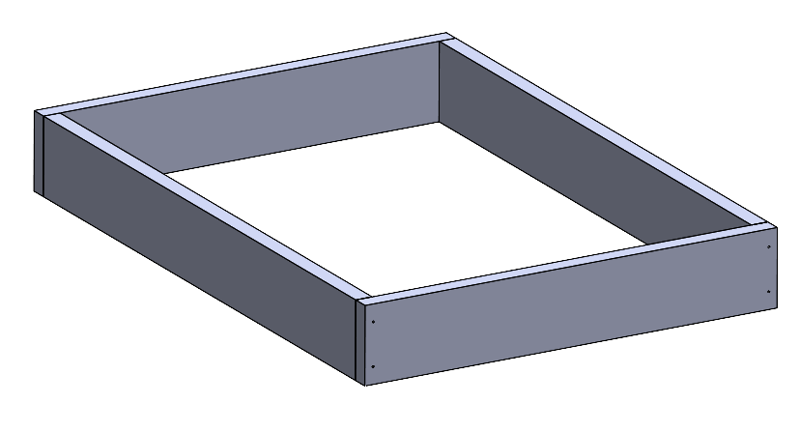  D  D  D  D  D  D  D  D  B | 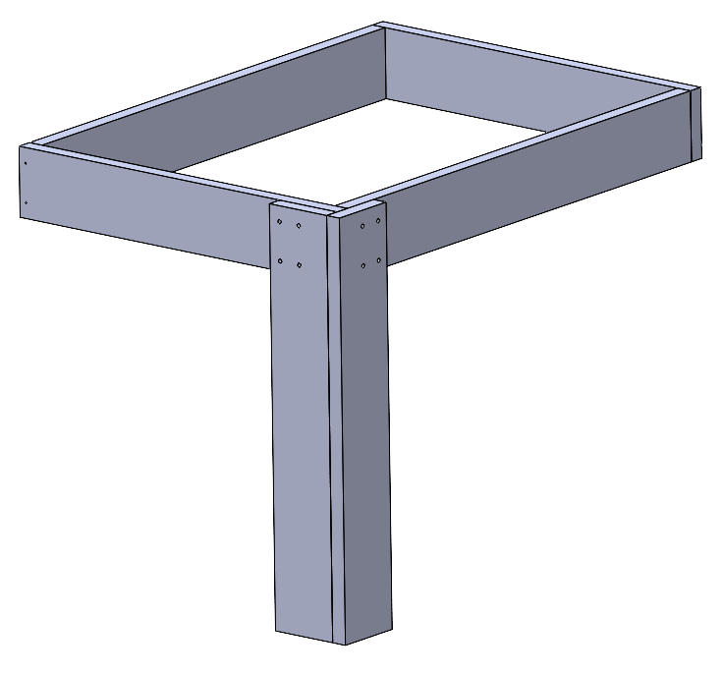  2xD  x2  2xD  x2  2xD  x2  2xD  x2  C |   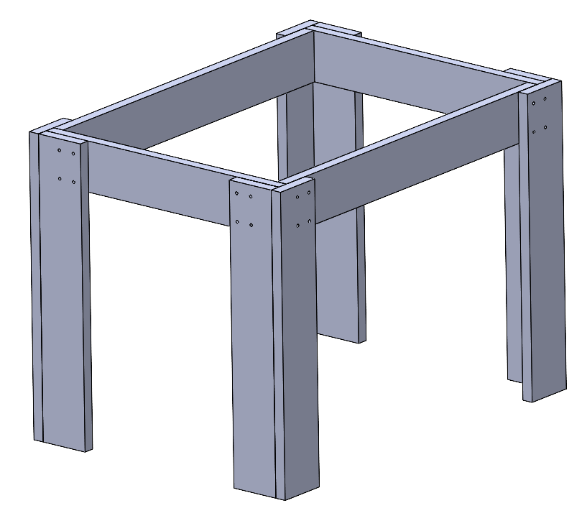  5  C  C  C | 
4 | 5 | 6 | 7
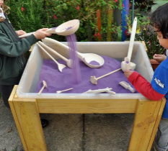
 |  |  | 2 |  |  | 2 |  |  | 4 |  | 
 |  | 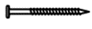 35mm |  |  |  | 1

