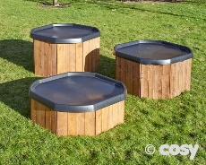
 |  | 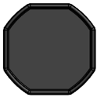 | 3 |  | 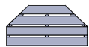 | 6 |  | 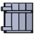 | 4 |  | 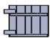 | 4 |  | 
 |  | 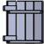 | 4 |  | 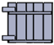 | 4 |  | 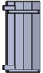 | 4 |  | 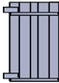 | 4
 |  | 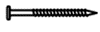50mm | 84

28106 – Tuff Spot Super Store (3 heights)
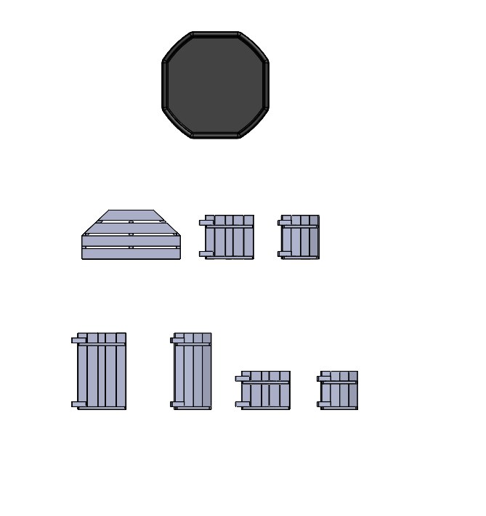  Cx4  Dx4  Gx4  Hx4  Ax3  Ex4  Fx4  Bx6 | 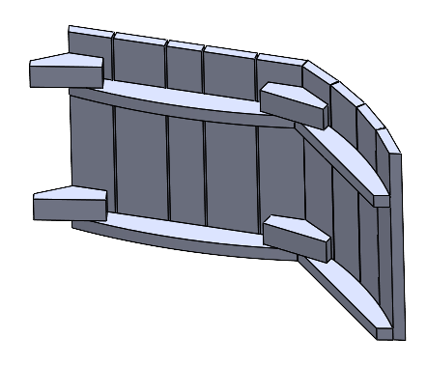  F  E | 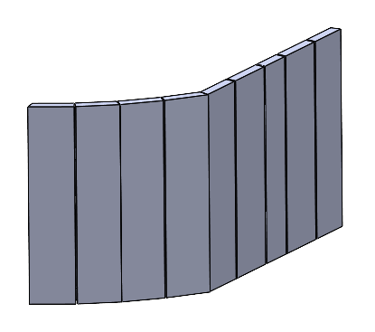  I  I  I  I
 | 2 | 3
 | 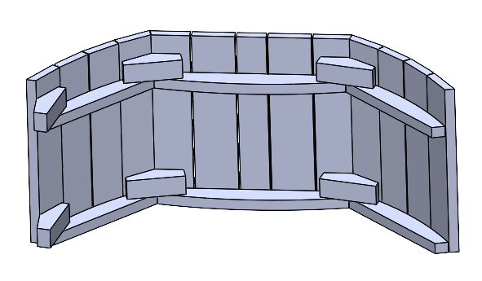  E | 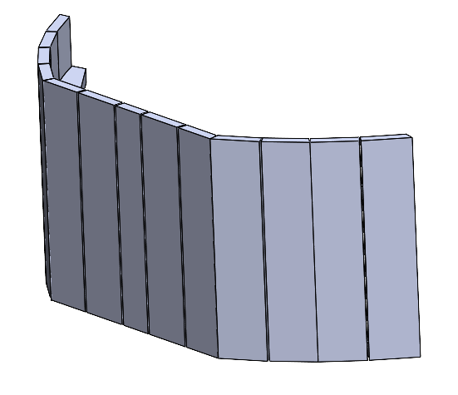  I  I  I  I
1 | 4 | 5

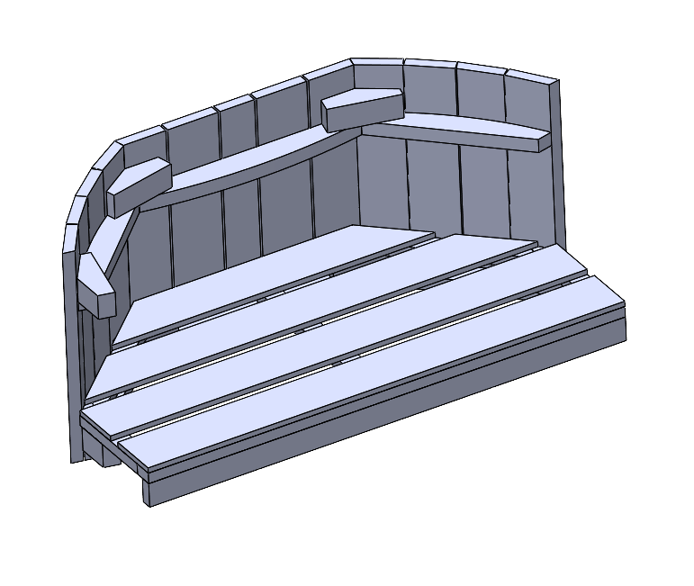  B |   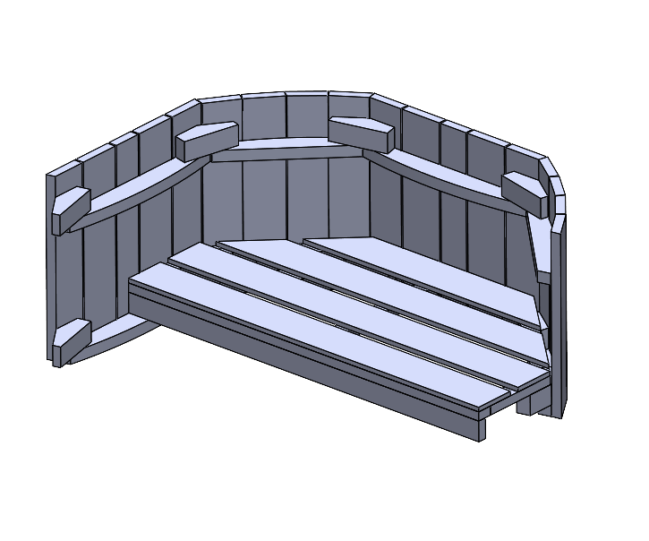  F | 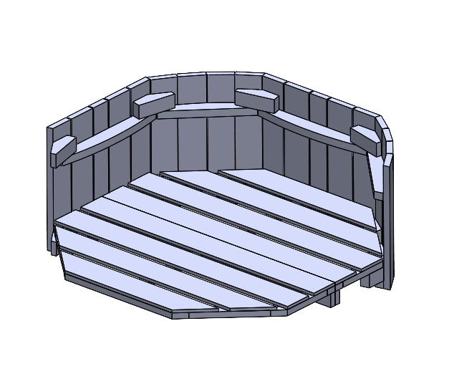 |   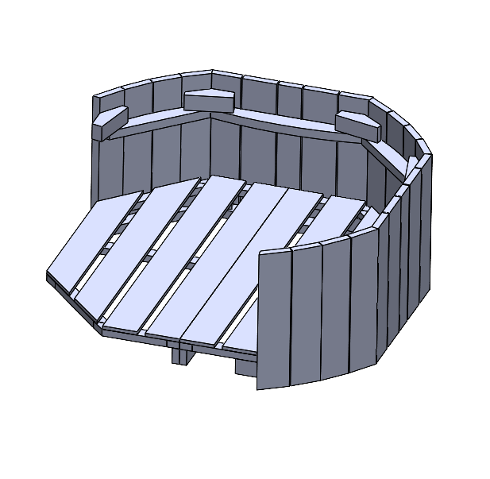  5  E
6 | 7  5 | 8  B | 9
  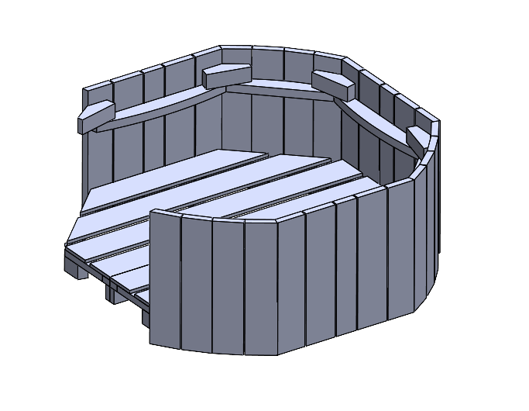  5  F | 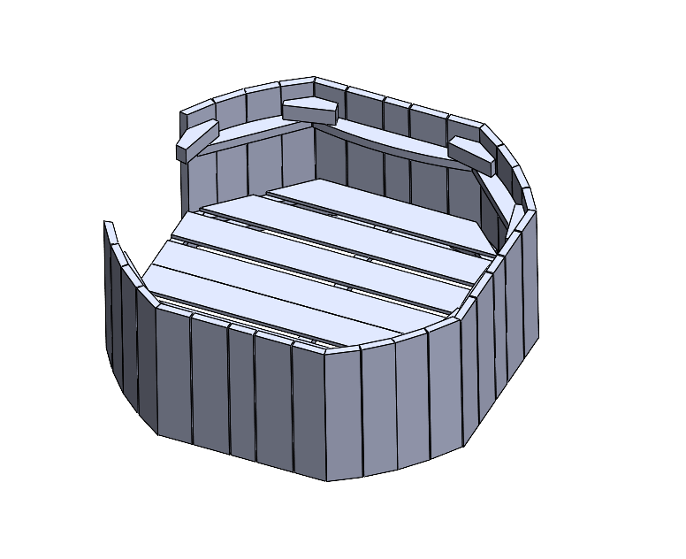  5  E | 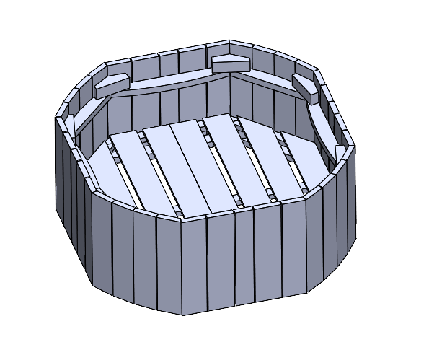  5  F
10 | 11 | 12 | 13

2 - 12  C  D  D  D  D  C  C  C | 2 - 12  H  H  H  G  G  G  H  G | 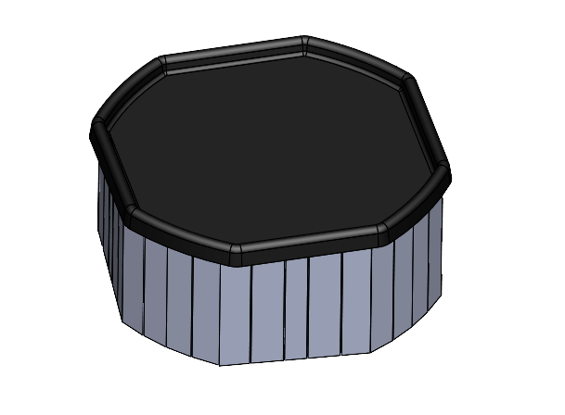  Ax3 | 
14 | 15 | 16 | 17

